Image Transfer Reality Using

Augmented Reality & Artificial Intelligence

N. YEDUKONDALU Asst Professor, Department of CSE, Narayana Engineering College Gudur, AP, sevenhills.559@gmail.com

N. SAI YASWANTH REDDY, Department of CSE, Narayana Engineering College Gudur, AP, nelloreyashwanthreddy@gmail.com

R. SUBRAMANYAM, Department of CSE, Narayana Engineering College Gudur, AP, subburs987@gmail.com

N. VENKATESH, Department of CSE, Narayana Engineering College Gudur, AP, venkateshskht67@gmail.com

Abstract— The huge mechanical headways all throughout the planet have made critical testing rivalry among organizations where every one of the organizations attempts to pull in the clients utilizing various procedures. One of the new procedures is Augmented Reality (AR). The AR is another innovation which is fit for introducing conceivable outcomes that are hard for different advancements to offer and meet. Increase Reality tool that can catch pictures of true articles and add them to a PC program in almost no time. AR Copy Paste allows clients to snap a picture of an article in reality and drop the picture into a work station program with a couple of straightforward activities on their PDA. The application utilizes expanded reality (AR) and AI innovation to identify objects in reality and separate the picture with the goal that the foundation is naturally taken out. Clients at that point move the advanced cell over their PC screen to glue the item picture into a viable PC program, for example, Photo shop or In Design.

Keywords— Augmented Reality, Drag and Drop, Mobile, Expo app , BASNET , U2 Net , Photoshop.

Introduction
The AR is another innovation which is fit for introducing potential outcomes that are hard for different advancements to offer and meet. These days, various increased reality applications have been utilized in the business of various types and spread everywhere on the world .AR Copy Paste permits clients to snap a picture of an item in reality and drop the picture into a personal computer program with a couple of basic activities on their cell phone. The application utilizes increased reality (AR) and AI innovation to distinguish objects in reality and seclude the picture with the goal that the foundation is naturally eliminated. Clients at that point move the cell phone over their PC screen to glue the item picture into a viable PC program, like Photoshop or InDesign. AR Copy Paste can be utilized on Android, iOS and work areas related to various applications, like Adobe Creative Suite, Powerpoint, Keynote, MS Paint and Google Docs. I have utilized open-source innovations created as a component of two examination projects: the Boundary-
Aware Salient Object Detection (BASNet) and Scale Invariant Feature Transform (SIFT).
The BASNET is a Deep Convolution Neural Networks have been embraced for notable item location and accomplished the cutting edge execution. The greater part of the past works anyway center around locale exactness however not on the limit quality. In this paper, we propose an anticipate refine engineering, BASNet, and another half breed misfortune for Boundary-Aware Salient article recognition. In particular, the engineering is made out of a thickly directed Encoder-Decoder organization and a lingering refinement module, which are individually accountable for saliency expectation and saliency map refinement. The half breed misfortune directs the organization to become familiar with the change between the info picture and the ground truth in a three-level chain of importance - pixel-, fix and guide level - by melding Binary Cross Entropy (BCE), Structural Similarity (SSIM) and Intersection-over-Union (IoU) misfortunes. Furnished with the half breed misfortune, the proposed foresee refine engineering can viably fragment the striking item areas and precisely anticipate the fine designs with clear limits. Trial results on six public datasets show that our technique beats the cutting edge strategies both as far as local and limit assessment measures. Our strategy runs at more than 25 fps on a solitary GPU. Salient Object Detection (SOD) targets dividing the most outwardly appealing items in a picture. It is broadly utilized in numerous fields, for example, visual following and picture division. As of late, with the advancement of profound convolution neural organizations (CNNs), particularly the ascent of Fully Convolution Networks (FCN) in picture division, the striking article recognition has been improved altogether. It is normal to ask, what is as yet absent? How about we make a stride back and take a gander at the excess difficulties. There is a typical example in the plan of most SOD networks [18, 27, 41, 6], that is, they center around utilizing profound highlights extricated by existing spines, for example, Alexnet [17], VGG [35], ResNet [12], ResNeXt [44], Dense Net [15], and so forth There are a couple of more issues on the organization structures for SOD. In the first place, they are frequently excessively convoluted [58]. It is part of the way because of the extra component collection modules that are added to the current spines to remove staggered saliency highlights from these spines. Furthermore, the current spines typically accomplish further design by forfeiting high goal of highlight maps [58]. To run these profound models with moderate memory and computational expense, the element maps are down scaled to bring down goal at beginning phases.
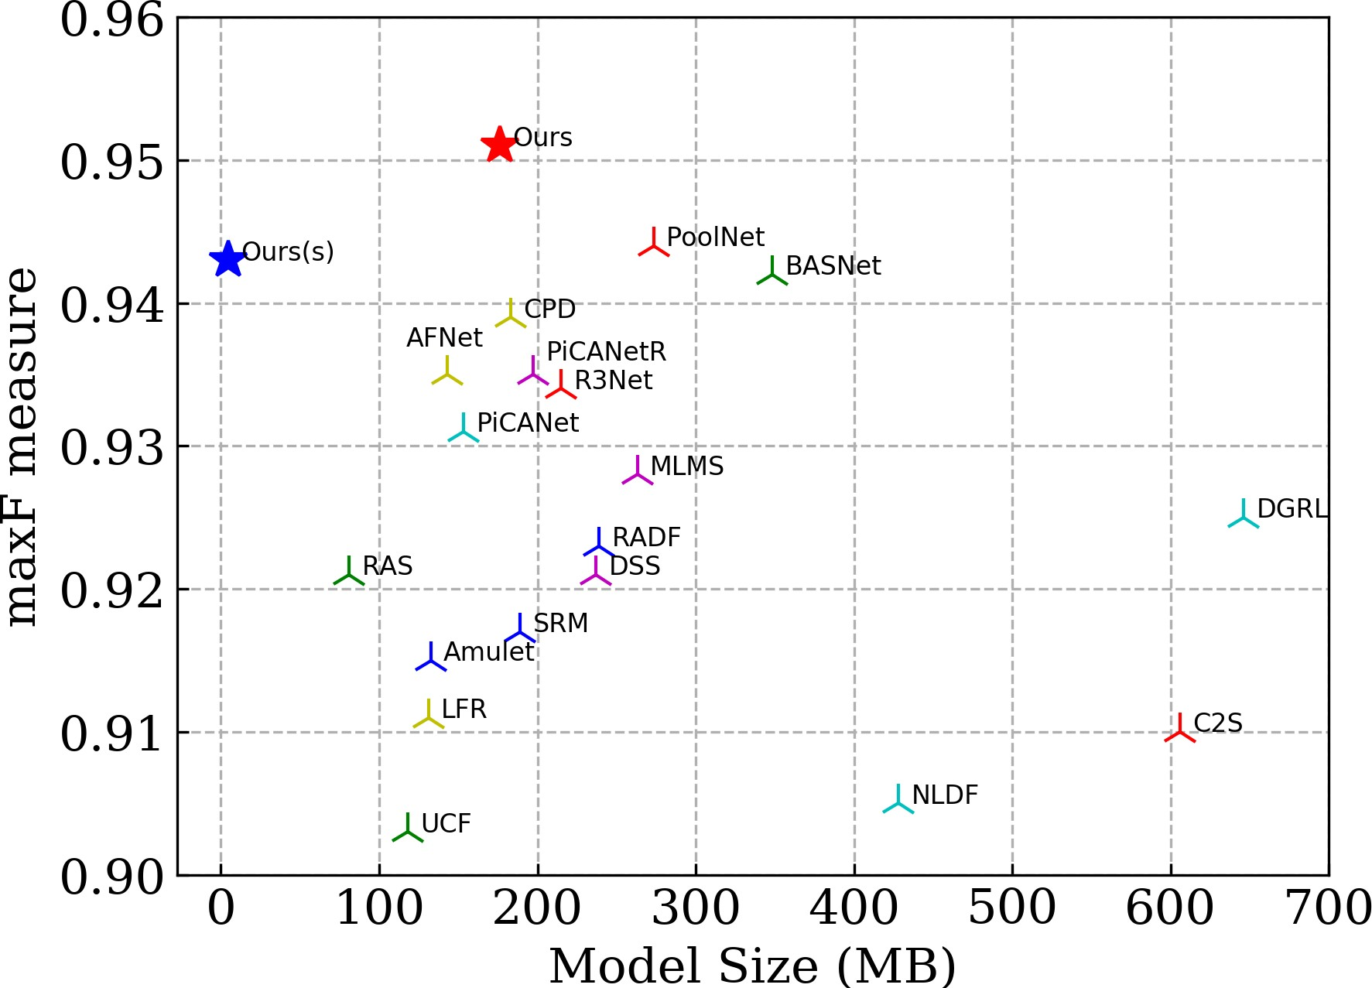
Figure 1. Comparison of model size and performance
U2 -Net with other state-of-the-art SOD models. The max measure is computed on data set ECSSD. The red star denotes our U2 -Net (Ours) (176.3 MB) and the blue star denotes our small version U2 -Net† (Ours†).
This leads to our first question: can we design a new network for SOD, that allows training from scratch and achieves comparable or better performance than those based on existing pre-trained backbones?

There are a couple of more issues on the organization structures for SOD. In the first place, they are regularly excessively confounded [58]. It is incompletely because of the extra component conglomeration modules that are added to the current spines to extricate staggered saliency highlights from these spines. Besides, the current spines typically accomplish further engineering by forfeiting high goal of highlight maps [58]. To run these profound models with moderate memory and computational expense, the component maps are down scaled to bring down goal at beginning phases. For example, at the early layers of both ResNet and DenseNet [15], a convolution with step of two followed by a maximum pooling with step of two are used to diminish the size of the component guides to one fourth of information guide of tour principle commitment is a novel and basic organization engineering, called U 2 - Net, that tends to the two inquiries above. In the first place, U2 - Net is a two-level settled U-structure that is intended for SOD without utilizing any pre-prepared spines from picture grouping. It very well may be prepared without any preparation to accomplish cutthroat execution. Second, the novel engineering permits the organization to go further, achieve high goal, without fundamentally expanding the memory and calculation cost. This is accomplished by a settled U-structure: on the base level, we plan a novel ReSidual U-block (RSU), which can remove intra-stage multi-scale highlights without corrupting the element map goal; on the high level, there is a U-Net like construction, where each stage is filled by a RSU block. The two-level setup brings about a settled U-structure (see Fig. 5). Our U2 - Net (176.3 MB) accomplishes serious execution against the condition of-theart (SOTA) techniques on six public datasets, and runs at constant (30 FPS, with input size of 320×320×3) on a 1080Ti GPU. To work with the use of our plan in calculation and memory obliged conditions, we give a little form of our U2 - Net, called U 2 - Net† (4.7 MB). The U2 - Net† accomplishes serious outcomes against the majority of the SOTA models (see Fig. 1) at 40 FPS.

RELATED WORK:
The Drag and drop usefulness in our interface utilizes a similar strategy as most other GUI highlights drag source occasions, and drop occasions. To deal with these occasions, we execute the relating audience interfaces. This interaction should sound natural to any individual who has set up occasion overseers for other GUI segments. For instance, to react to a dropped object (reusable part), we make an occasion overseer that carries out the Drop Target Listener interface.
A Drag Source appears, related with some show Component in the GUI, to start a Drag and Drop of some possibly Transferable of reusable parts. The Drag Source object shows "Drag Over" criticism to the client, in the average case by enlivening the GUI Cursor related with the sensible cursor. In the event that we need a solitary D&D-empowered segment, we can make a subclass that characterizes Drag Gesture Listener, Drag Source Listener, and Drop Target Listener as inward classes. In the event that client needs various D&D-empowered segments, client will compose very much like code for every part's audience members. As referenced before, saliency discovery requires both neighborhood and worldwide data. A 3 × 3 channel is useful for extricating neighborhood highlights at each layer. Be that as it may, it is hard to extricate worldwide data by essentially expanding the channel size since it will build the quantity of boundaries and calculation costs significantly. Numerous works focus closer on separating worldwide setting. Wang etal. (SRM) [40] adjust the pyramid pooling module [57] to catch worldwide setting and propose a multi-stage refinement instrument for saliency maps refinement. Zhang etal. (PAGRN) [56] foster a spatial and a channel-wise consideration module to acquire the worldwide data of each layer and propose a reformist consideration direction component to refine the saliency maps. Wang et al. (DGRL) [41] foster an initiation like [36] context oriented weighting module to limit striking items worldwide and afterward utilize a limit refinement module to refine the saliency map locally. Liuetal. (PiCANet) [23] intermittently catch the neighborhood and worldwide pixel-wise relevant consideration and foresee the saliency map by joining it with an UNet design. Zhangetal. (CapSal) [51] plan a nearby and worldwide insight module to separate both neighborhood and worldwide data from highlights removed by spine organization. Zengetal. (MSWS) [48] plan a consideration module to anticipate the spatial appropriation of forefront objects over picture areas in the meantime total their highlights. Fengetal. (AFNet) [9] foster a worldwide insight module and mindful criticism modules to all the more likely investigate the construction of notable items. Qinetal. (BASNet) [33] propose an anticipate refine model by stacking two in an unexpected way

METHODOLOGY:
A drag-empowered segment executes the Drag Component interface. It makes a case of Drag Gesture Adapter and a case of Drag Source Adapter. The Drag Source Adapter carries out the Drag Source Listener interface and keeps a reference to a Drag Component object. At the point when a drag is started, the Drag Source Adapter inquiries the Drag Component for the worthy drag activity and a fitting Transferable object(reusable part). On the off chance that this is a move activity, the Drag Source Adapter will advise the Drag Component to move the segment. The move activity really adds the information to the objective, at that point eliminates the information from the source toward the finish of the D&D activity. These are normally cursor changes. The Drag Component utilizes a Drag Gesture Adapter object, which carries out the Drag Gesture Listener interface, to start the part drag activity. With segments like a JTree, it is conceivable that not everything hubs can be hauled. The Drag Gesture Adapter checks the drag with the Drag Component's is Start Drag Ok() technique, and it enlists the Drag Component's Drag Source Adapter.

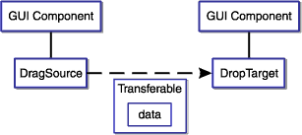
Figure 2. Drag & Drop
A drop-empowered segment executes the Drop Component interface. The execution is appeared in Below figure (2). Most projects can profit by the capacity to move data, either between segments, between Java applications, or among Java and local applications Drag and drop (DnD) support. The accompanying graph shows the Java bit of a drag activity in our interface.

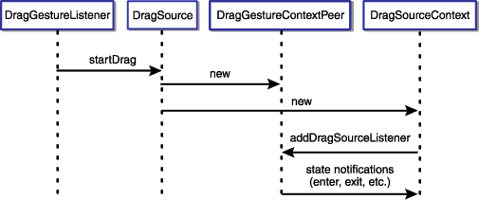

Figure 3. Drop component Interface
SIFT ALGORITHM:
SIFT helps locate the local features in an image. commonly known as the ‘keypoints‘ of the image. These keypoints are scale and revolution invariant that can be utilized for different PC vision applications, similar to picture coordinating, object recognition, scene location, and so on We can likewise utilize the keypoints produced utilizing SIFT as highlights for the picture during model training. The significant benefit of SIFT highlights, over edge highlights or hoard highlights, is that they are not influenced by the size or direction of the picture.
1. Scale-space peak selection: Potential location for finding features.
2.Keypoint Localization: Accurately locating the feature
Keypoint
3.Orientation Assignment: Assigning orientation to key points

4. Keypoint descriptor: Describing the keypoints as a high dimensional vector.

5. Keypoint Matching.

Scale-space peak selection:

Certifiable items are significant just at a specific scale. You may see a sugar shape completely on a table. Yet, on the off chance that taking a gander at the whole smooth way, it just doesn't exist. This multi-scale nature of items is very basic in nature. What's more, a scale space endeavours to repeat this idea on advanced pictures. The scale space of a picture is a capacity L(x,y,σ) that is created from the convolution of a Gaussian kernel(Blurring) at various scales with the info picture. Scale-space is isolated into octaves and the quantity of octaves and scale relies upon the size of the first picture. So we create a few octaves of the first picture. Every octave's picture size is a large portion of the past one.
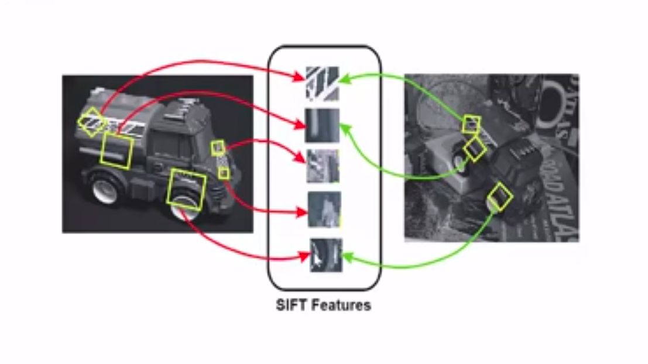

Figure 4. SIFT Features

Blurring:
Inside an octave, pictures are continuously obscured utilizing the Gaussian Blur administrator. Numerically, "obscuring" is alluded to as the convolution of the Gaussian administrator and the picture. Gaussian haze has a specific articulation or "administrator" that is applied to every pixel. What results is the obscured picture.

is the Gaussian Blur administrator and I is a picture. While x,y are the area directions and σ is the "scale" boundary. Consider it the measure of obscure. More prominent the worth, more noteworthy the haze.
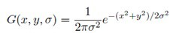

DOG (Difference of Gaussian kernel):

Presently we utilize those obscured pictures to produce another arrangement of pictures, the Difference of Gaussians (DoG). These DoG pictures are extraordinary for discovering fascinating keypoints in the picture. The distinction of Gaussian is gotten as the distinction of Gaussian obscuring of a picture with two extraordinary σ, let it be σ and kσ. This cycle is accomplished for various octaves of the picture in the Gaussian Pyramid. It is addressed in beneath picture:

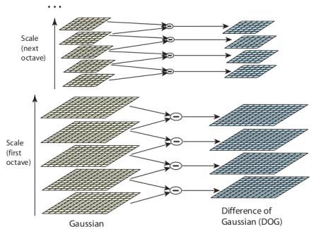

Figure 5. DOG
Finding keypoints:
Up till now, we have created a scale space and utilized the scale space to ascertain the Difference of Gaussians. Those are then used to figure Laplacian of Gaussian approximations that are scale invariant
One pixel in a picture is contrasted and its 8 neighbors just as 9 pixels in the following scale and 9 pixels in past scales. Thusly, a sum of 26 checks are made. On the off chance that it is a nearby extrema, it is a potential keypoint. It fundamentally implies that keypoint is best addressed around there.
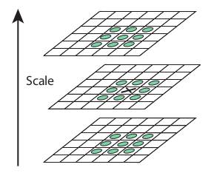
Figure 6. Finding Keypoints

Keypoint Localization:
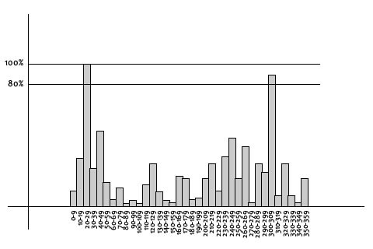
Key0points created in the past advance produce a great deal of keypoints. Some of them lie along an edge, or they need more difference. In the two cases, they are not as helpful as highlights. So we dispose of them. The methodology is like the one utilized in the Harris Corner Detector for removing edge highlights. For low differentiation highlights, we just check their powers. They utilized Taylor arrangement development of scale space to get a more exact area of extrema, and if the power at this extrema is not exactly an edge esteem (0.03 according to the paper), it is dismissed. Canine has a higher reaction for edges, so edges likewise should be taken out. They utilized a 2x2 Hessian lattice (H) to register the important curve.
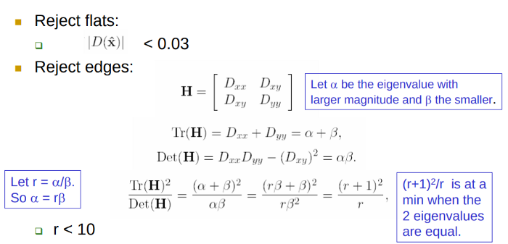
Up till now, we have made a scale space and used the scale space to determine the Difference of Gaussians. Those are then used to figure Laplacian of Gaussian approximations that are scale invariant.We currently have potential keypoints that address the pictures and are scale-invariant. We will apply the last check over the chose keypoints to guarantee that these are the most exact keypoints to address the picture. So what do we do about the excess keypoints? All things considered, we play out a check to distinguish the inadequately found keypoints. These are the keypoints that are near the edge and have a high edge reaction however may not be powerful to a limited quantity of clamor. A second-request Hessian framework is utilized to distinguish such keypoints. You can go through the math behind this here.
Figure 7. keypoint process
Orientation Assignment:
Presently we have real keypoints. They've been tried to be steady. We definitely know the scale at which the keypoint was identified (it's equivalent to the size of the obscured picture). So we have scale invariance. The following thing is to dole out a direction to each keypoint to make it turn invariance. An area is taken around the keypoint area relying upon the scale, and the inclination greatness and heading is determined around there. A direction histogram with 36 canisters covering 360 degrees is made. Suppose the inclination heading at one point (in the "direction assortment locale") is 18.759 degrees, at that point it will go into the 10–19-degree canister. Also, the "sum" that is added to the receptacle is corresponding to the size of the slope by then. Whenever you've done this for all pixels around the keypoint, the histogram will have a top sooner or later.
Figure 8. graph orientation

Keypoint Matching:

Keypoints between two pictures are coordinated by distinguishing their closest neighbors. Be that as it may, now and again, the second nearest match might be close to the first. It might occur because of commotion or some different reasons. Around there, the proportion of nearest distance to second-nearest remove is taken. In the event that it is more noteworthy than 0.8, they are dismissed. It wipes out around 90% of bogus matches while disposes of just 5% right matches, according to the paper.

RESULTS AND ANALYSIS:
In this paper we portray a situation where by the fashioner/client can work however much as could reasonably be expected of the custom application by intelligently and graphically hauling parts out of a brilliant item bag, determining their accurate conduct by straightforwardly altering their traits, at that point graphically interfacing them to different articles by intuitive, and reuse that dropped segments.
Our GUI interface supports to drag the segments from GUI interface to Logical cursor. The dropped part is reused with its interface detail and business rationales. The Drag Under usefulness is appeared in the Figure (6).This Figure shows a java document is hauled from neighborhood drive of a similar framework and dropped into our Interface. This interface is go about as an archive to store the dropped segments into that. The Drop Target object shows.
The mystery ingredient for replicating the item, as Cyril Diagne specifies in his tweet, is the BASNet. This foresee refine engineering empowers the ID of this present reality article and veils it out from its encompassing. Until date, different procedures have advanced for object recognition zeroed in on area exactness however not on the limit quality. Comparable to the human vision framework, which has a viable consideration component for picking fundamental data from visual scenes, this PC vision strategy expects to show this system through remarkable article discovery. BASNet centers and focuses on precisely fragmenting the pixels of unmistakable items in an info picture.
BASNet accomplishes exact striking item division with great limits. Articles at that point are glued into the working. screen utilizing screen-point, a Python library that proselytes camera centroid into screen arranges utilizing the OpenCV SIFT calculation. D. Lowe, of the University of British Columbia, concocted, Scale Invariant Feature Transform (SIFT) calculation. The calculation can remove key focuses, process its descriptors, and match comparing key focuses between two pictures by recognizing their closest neighbors. This calculation comprehends where the telephone focuses are at the screen by coordinating with the directions of the camera with the screen, the subsequent fixing permitting situating of the image.The inertness rate determined by the engineer for this activity was roughly around 2.5s for replicating and 4s for gluing, diminishing minutes of pound to a couple of moments. Simply seven days after his first video of the model, the Greek software engineer found considerably more noteworthy outcomes about object identification utilizing U^2-Net, a continuation of BASNet.
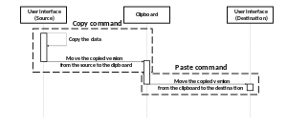
Figure 9. working flow

AR reorder isn't only an Augmented Reality duplicate glue photoshop change – it has an enhanced scope of utilizations and can be utilized related to an assortment of applications like Adobe Creative Suite, Powerpoint, Keynote, MS Paint and Google Docs. Envision you have a show to offer, and to make it effective. you need to add true items or append pictures from course readings. Rather than clicking a snap, concealing it out in an alternate application, and afterward sticking it into slides with the assistance of AR reorder, you'd should simply examine the picture and point it down to your slide and Voila! The model can't just be glued on different workspace applications however can likewise duplicate printed messages from course readings close by pictures. By choosing printed exposition, they would now be able to be duplicated and attached to your ideal workspace, similar to Word and Photoshop, saving you arduous endeavors of composing the content once more by couple of snaps..
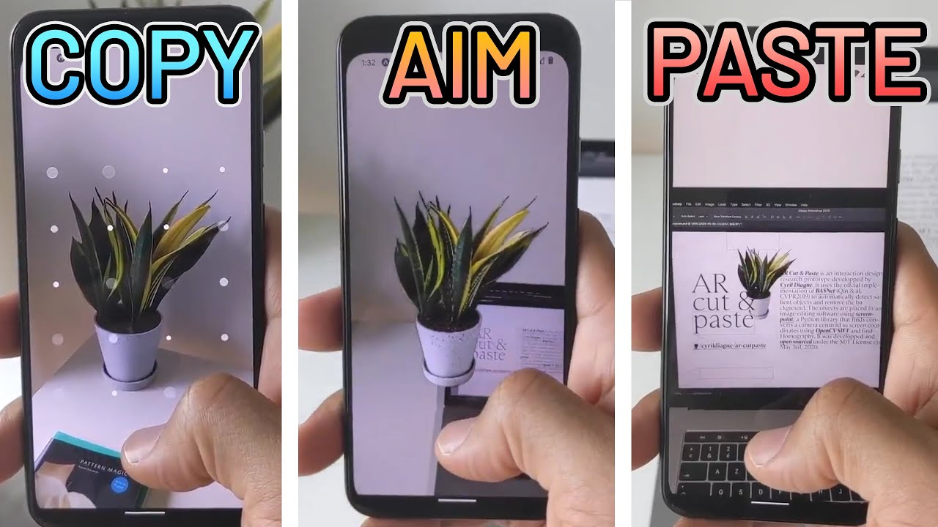
Figure 10. final output
The way toward gluing certifiable items by tapping the snap of an article, disposing of its experience, and imparting it to your work area is a drawn-out one. With this Augmented Reality App, it replaces this entire interaction by pointing your camera choosing the ideal article, making it effective by bypassing snapping, veiling, saving, and exchanging windows for the client – making it exceptionally proficient AR duplicate glue photoshop change. The entire interaction is similar to a pick-and-spot robot, with the telephone as the end effector or the hook snatching the ideal article subsequent to isolating it from the foundation and setting it to the ideal open workspace just by guiding the telephone toward the screen. Expanded Reality Drag and Drop permits clients to snap a picture of an item in reality and drop the picture into a PC program with a couple of straightforward activities on their cell phone. The application utilizes expanded reality (AR) and AI innovation to identify objects in reality and disconnect the picture with the goal that the foundation is consequently eliminated. Clients at that point move the cell phone over their PC screen to glue the item picture into a viable PC program, like Photoshop , Any Softwares .cks..

FUTURE ENHANCEMENT:

- In the fields of plan, it can help decrease the latency for clients to decipher hand-drawn or antiquated outline directly into your workspace in practically no time.

- For the scholarly community related assignments, AR reorder can help make a more successful show, computerize carrying printed writings to your advanced workspace

- Searching experience particularly can be made more intuitive, more liquid, expanding the client experience on the off chance that we can duplicate genuine content, photographs, sounds, and glue them straightforwardly to look through bars.

- It can make client commitment: Games or applications can be made more client connecting with, simply envision utilizing Augmented Reality for advanced world Treasure-Hunt games wherein you need to duplicate glue genuine items.

- If your tech is made open to this innovation like AR duplicate glue photoshop, it very well may be brought to various work spaces like printers or projectors, Augmented Reality can help print or venture a true article inside a couple of snaps and snaps.

- AR Copy Paste allows clients to snap a picture of an item in reality and drop the picture into a personal computer program with a couple of straightforward activities on their shrewd phon

- Make sure to arrange an alternate port in case you're running BASNet on a similar PC as the nearby help .

- Expo is a structure and a stage for all inclusive React
applications is a bunch of apparatuses and administrations worked around React Native and local stages that help you create, fabricate, send, and rapidly emphasize on iOS, Android, and web applications from a similar JavaScript/TypeScript , codebase.

CONCLUSION:
Expanded Reality duplicate glue, subsequently isn't only an AR duplicate glue photoshop application however can have a horde of uses and augmentations. Simply the way applications like Whatsapp, Swiggy, Amazon have gotten imbued to our everyday way of life supplanting conventional messaging, Food orders, conveyance. Expanded reality

applications like Augmented Reality duplicate glue will not set aside much effort to turn outto be natural and again advise us that innovations have the responses to break our everyday confronted limits This work proposed an increased reality-based communication method for record move in numerous PC conditions. In particular, we give another connection procedure to numerous record move in non truly co-found presentations. This method might be simpler to utilize and more normal than customary procedures, because of the inescapability of cellphones and because of the way that the proposed strategy utilizes a few notable cooperation strategies (intuitive, tapping/tapping on documents) and cell phone capacities (applications, telephone camera). .
The capacity to allow clients to drag segments from their Interfaces into our application is very nearly a necessity of a cutting edge, business UI [1]. Reusable parts planned with "Simplified" style enjoy numerous upper hands over plans dependent on the customary "duplicating style," [4] including improved execution effectiveness, higher dependability and upgraded reusability. Throughout the long term intuitive has gone from a cool component to a necessary piece of most UIs. Creating reusable segments programming requires a creator to decide how to structure a product framework to accomplish the fundamental usefulness, while simultaneously expanding the reuse capability of the product. Part recognizable proof [6] fixates on the application's area, with reuse zeroing in explicitly on an association's future frameworks. The primary methodology is to arrange parts, distinguish segment limits, and determine where segments are connected. Our archive is carried out to help measure for segment reuse utilizing simplified component. At the point when the part designers perform segment based tasks, our store gives reuse offices that are essentially needed during segment based turn of events. In this paper, we proposed a novel profound organization: U2 - Net, for notable item location. The principle engineering of our U2 - Net is a two-level settled U-structure. The settled Ustructure with our recently planned RSU blocks empowers the organization to catch more extravagant nearby and worldwide data from both shallow and profound layers paying little mind to the goals.

REFERENCES:

[0] Dr.Cyrill Diagne , He is ML + HCL – Co-founder @initml Previously: Artist in residence @Googleartsculture Professor & Head of @ecal – mid , Co-founder of lab212.org

[1] R. Achanta, S. Hemami, F. Estrada, and S. Susstrunk. Recurrence tuned notable area identification. In 2009 IEEE Conference on Computer Vision and Pattern Recognition, pages 1597–1604, 2009.

[2] Ali Borji, Ming-Ming Cheng, Huaizu Jiang, and Jia Li. Remarkable item identification: A benchmark. IEEE Trans. Picture Processing, 24(12):5706–5722, 2015.

[3] Liang-Chieh Chen, George Papandreou, Iasonas Kokkinos, Kevin Murphy, and Alan L Yuille. Deeplab: Semantic picture division with profound convolutional nets, atrous convolution, and completely associated crfs. IEEE exchanges on design examination and machine insight, 40(4):834–848, 2017.

[4] Shuhan Chen, Xiuli Tan, Ben Wang, and Xuelong Hu. Invert consideration for remarkable item discovery. In Proceedings of the European Conference on Computer Vision (ECCV), pages 234–250, 2018.

[5] Jia Deng, Wei Dong, Richard Socher, Li-Jia Li, Kai Li, and Li Fei-Fei. Imagenet: A huge scope progressive picture data set. In 2009 IEEE gathering on PC vision and example acknowledgment, pages 248–255. IEEE, 2009.

[6] Zijun Deng, Xiaowei Hu, Lei Zhu, Xuemiao Xu, Jing Qin, Guoqiang Han, and Pheng-Ann Heng. R3net: Recurrent remaining refinement network for saliency discovery. In Proceedings of the 27th International Joint Conference on Artificial Intelligence, pages 684–690. AAAI Press, 2018.

[7] Marc Ehrig and Jer' ome Euzenat. Loosened up exactness and re-ˆ call for cosmology coordinating. In Proc. K-Cap 2005 workshop on Integrating philosophy, pages 25–32. No business manager., 2005.

[8] Deng-Ping Fan, Ming-Ming Cheng, Yun Liu, Tao Li, and Ali Borji. Design measure: another approach to assess forefront maps. In Proceedings of the IEEE Conference on Computer Vision and Pattern Recognition, pages 4548–4557, 2017.

[9] Mengyang Feng, Huchuan Lu, and Errui Ding. Mindful criticism network for limit mindful striking article location. In Proceedings of the IEEE Conference on Computer Vision and Pattern Recognition, pages 1623–1632, 2019.

[10] Xavier Glorot and Yoshua Bengio. Understanding the trouble of prepareng profound feedforward neural organizations. In Proceedings of the Thirteenth International Conference on Artificial Intelligence and Statistics, AISTATS, pages 249–256, 2010.

[11] Robert M Haralick, Stanley R Sternberg, and Xinhua Zhuang. Picture investigation utilizing numerical morphology. IEEE exchanges on design investigation and machine insight, (4):532–550, 1987.

